Care & Maintenance of Stainless Steel Cutlery

Cutlery made from Stainless Steel is highly resistant to stains and corrosion as it is one of the most durable metals available.
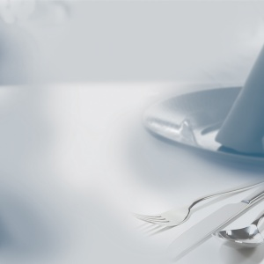
To ensure long life and to retain the lustre, the following procedures are recommended:
• Remove all food remnants and rinse immediately.
The prolonged exposure to certain foods, for example eggs, lemon, mustard, salt & tomato will stain if not rinsed immediately.
• Wash in hot water using a good quality detergent
• Cutlery MUST be dried completely before storing to prevent water stains.

To remove stubborn marks, use a mild abrasive. To remove stubborn water stains use methylated spirits and/or vegetable oil. After removing stains, dip in hot water, then wipe with soft cloth.

Grades of stainless steel used for cutlery
There are various grades of stainless steel used in the manufacture of
cutlery. In the main, cutlery falls into three grades, so the higher the nickel content the better quality the cutlery will be.
18/10 – 18% Chromium / 10% Nickel
18/8 – 18% Chromium / 8% Nickel
18/0 – 18% Chromium– having no nickel, this grade is prone to rust spots

